Below is the usual core and hips circuit followed during drills sessions by long sprints, middle distance and cross country. Feel free to increase the reps, add some of your own exercises or do multiple sets of the circuit if you’re not doing it alongside a larger session such as drills or S&C etc.
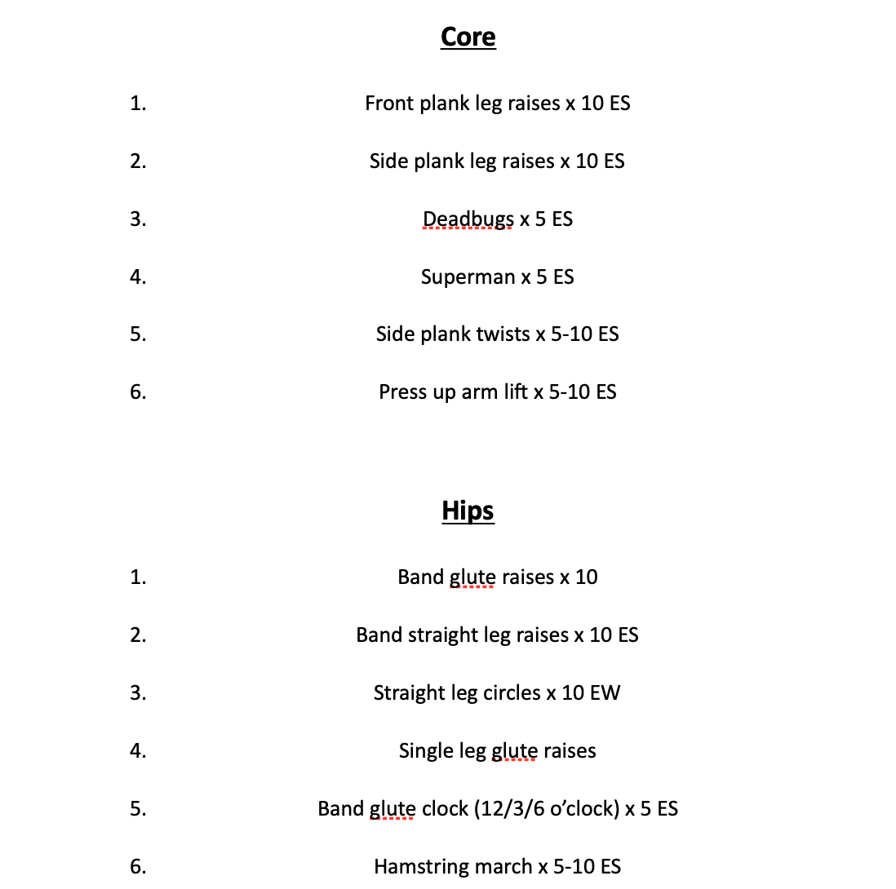
Enjoy!

